ANAESTHESIA FOR OVUM RETRIEVAL
Dr.K.Santhaarulmozhi MD.DA, Professor of Anaesthesiology
Coimbatore Medical College

INTRODUCTION :
In-vitro fertilisation with embryo transfer is a well established treatment for various causes of Infertility. In earlier days ovum retrieval was done under trans abdominal laparoscopy.Nowadays it is done transvaginally under ultrasound guidance. Although less invasive than the laparoscopic approach trans-vaginal oocyte retrieval may be very painful.This topic gains importance because the target population will be young and healthy and any untoward incident will be detrimental.Patients will be under high degree of stress and anxiety and might need repeated attempts so they should not be left with unpleasant memories.Our anaesthetic technique should not affect the quality of retrieved ovum and the fertilisation rate.Pain level may be affected by number of factors such as patient charcteristics,operator skill and the technique. Patient factors include pain threshold , level of anxiety ,position and mobility of ovaries and number of follicles punctured.
PROCEDURE :
Trans-vaginal route under ultrasound guidance is preferred nowadays.Though it is a procedure lasting for a short duration of 20 to 30 minutes it can be quiet painful.Patient has to be put in lithotomy position .A 16G double channel needle fitted to a 5mhz vaginal ultrasound probe. Double channel needle allows aspiration and flushing of follicles. One puncture is made on each side . Each follicle is flushed with culture media and the fluid from aspirate and flushing will be examined for oocyte.
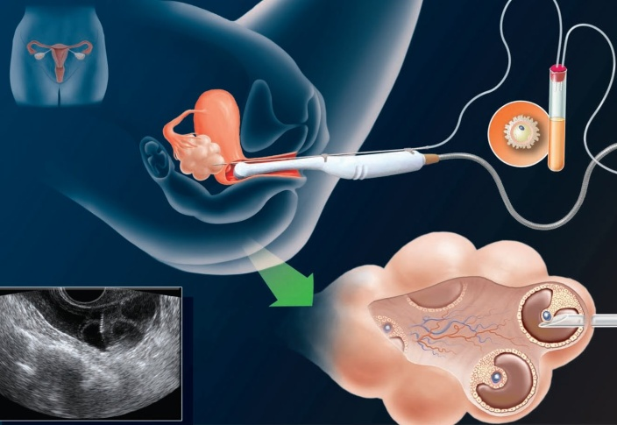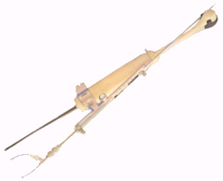

Ovum retrieval- Procedure Double channel needle with USG probe

Problems Involved :
1.Young patient group with lot of stress and anxiety.
2.Possible need for repeated anaesthetics.
3.Any co-morbid illness and drug intake.
4. Quality of the retrieved oocyte and process of fertilisation should not be affected by the anaesthetic drugs or procedures.

ANAESTHESIA :
Ideal pain relief during oocyte retrieval should be effective and safe, easy to administer and monitor, short acting and readily reversible with few side effects.
Patients should be thoroughly evaluated to identify any co-morbid illness.History of any drug intake should be taken and possible anaesthetic implications of the drugs should be taken into consideration. All patients should be starved atleast for 6 hrs.
Options available:
1.Local Anaesthesia -Paracervical block and Pre ovarian block.
2.Conscious sedation with or without local blocks.
3.General Anaesthesia.
4.Regional Techniques- Spinal or Epidural.

LOCAL ANAESTHESIA :
Paracervical block—can be used along with IV sedation in a cooperative patient.This block seems to be very effective and safe and doesn”t alter the outcome much.5ml of 1%Lignocaine injected through a 21G needle at 4 and 8 o ‘clock positions into the vaginal vault.It Anaesthetises both vaginal mucosa and peritoneal membrane over pouch of douglas and uterosacral ligaments.
Pre ovarian block---Local anaesthetic drug is injected under Ultrasound guidance in the vaginal wall and between vaginal wall and peritoneal surface near ovary 0.5ml of 1% lignocaine is injected on each side.This block is supposed to be as effective as para-cervical block especially in patients with a high BMI.

Monitored Anaesthesia care with Conscious Sedation:
Most commonly used method as it is relatively easy to deliver. Drugs are well tolerated and best suited for day care settings.It has its own risks involving cardiac , respiratory and anaphylactic complications.
Various sedation regimens have been tried. Combination of midazolam with fentanyl, Propofol with fentanyl and midazolam with ketamine have been tried &they appear safe. Propofol has an added advantage of antiemetic property along with faster recovery.The effect of propofol on the quality of retrieved oocyte and the fertilisation rate was extensively studied and found to be safe.Midazolam was found to be safe and effective.Fentanyl has minimal penetration into follicular fluid.Ketamine was also found to be a good alternative in combination with midazolam but recovery and street fitness takes a longer time.
General Anaesthesia :
Rarely used .Reserved for very apprehensive and uncooperative patient.Airway is secured either with endotracheal tube or Laryngeal mask airway.Isoflurane can be safely used with oxygen and air.Use of Nitrous oxide and Halothane can affect the outcome in fertilisation rate.
Spinal Anaesthesia :
It is also an effective method.Low dose hyperbaric1.5%lignocaine with 10 micrograms of fentanyl has been tried and found to be very effective.Bupivacaine has the disadvantage of having longer duration of action.
Epidural anaesthesia :
Forms a viable option but does not demonstrate any advantage over other techniques.
Alternative therapy :
Acupuncture-a traditional Chinese technique, by either manual or electrical stimulation.It is nontoxic&relatively affordable with the following advantages .
1.Sympatho inhibitory
2.Increased Beta endorphin levels
3.Antidepressant & Anxiolytic
4. Neuro-endocrine effect on hypothalamic pituitary ovarian axis.
5.Increased uterine blood flow.
It has been successfully used along with paracervical block or various conscious sedation techniques.

DISCUSSION :
Among various anaesthetic techniques used for ovum retrieval the technique of conscious sedation with a paracervical block seems to be a safe and effective technique.
With the upcoming large prospective trials, which documents the safe use of anaesthetic drugs, has widened the scope of more rationale anaesthesia in assisted reproductive techniques and extending our services to this developing sub-speciality.

REFERENCES :
1. T. Coetsier,M. Dhont, P. De Sutter, E. Merchiers, L. Versichelen and M.T. Rosseel - Propofol anaesthesia for ultrasound guided oocyte retrieval: accumulation of the anaesthetic agent in follicular fluid. Oxford Journals, Medicine & Health, Human ReproductionVolume 7, Issue 10,Pp. 1422-1424.

2.Ofer Gonen,Adrian Shulman, Yehudit Ghetler, Arieh Shapiro, Robert Judeiken, Yoram Beyt,Isaac Ben-Nun - The impact of different types of anesthesia on in vitro fertilization-embryo transfer treatment outcome. Clinical Assisted Reproduction. Journal of Assisted Reproduction and Genetics,November 1995, Volume 12, Issue 10,pp 678-682 .
3. Divya Jain, Amit Kohli, Lalit Gupta, PoonamBhadoria. Indian J Anaesth. 2009 Aug; 53(4): 408–413.Anaesthesia for In Vitro Fertilisation.
4.Trout SW, Vallerand AH, Kemmann E. Conscious sedation for in vitro fertilization used in paracervical block during oocyte retrieval. J Assist Reprod Genet. 2003;20:8–12.
5. Tanbo T, Henriksen T, Magnus O, Abyholm T. Oocyte retrieval in an IVF program. A comparison of laparoscopic and vaginal ultrasound guided follicular puncture. ActaObstetGynecol Scand. 1988;67:243–246.
6. Ng EH, Chui DK, Tang OS, Ho PC. Para cervical block with and without conscious sedation: a comparison of the pain levels during egg collection and the postoperative side effects. Fertil Steril.2001;75:711–717.
7. Stener-Victorin E. The pain-relieving effect of electro-acupuncture and conventional medical analgesic methods during oocyte retrieval: a systemic review of randomized controlled trials. Human Reproduction.2005;20:339–349.
8. Trout SW, Vallenand AH, Kemmann E. Conscious sedation for in vitro fertilization. Fertil Steril.1998;69:799–808.
9. Cerne A, Bergh C, Borg K, Ek I, Gejervall AL, Hillensjo T, Olofsson JI, Stener-Victorin E, Wood M, Westlander G. Pre-ovarian block versus paracervical block for oocyte retrieval. Human Reproduction.2006;21:2916–2921.
10. Stener-Victorin E, Waldenstrom U, Wiland M, Nilsson L, Hagglund L, Lundberg T. Electro-acupuncture as peroperative analgesic method and its effects on implantation rate and neuropeptide Y concentrations in follicular fluid. Human Reproduction. 2003;18:1454–1460.
11. Katzenschlager SMS, Wolfer MM, Langenecker SAK, Sator K, Sator PG, Li B, Heinze G, Sator MO. Auricular electro-acupuncture as an additional perioperative analgesic method during oocyte aspiration in IVF treatment. Human reproduction. 2006;21:2114–2120.
12. Bokhari A, Poland B. Anesthesia for assisted conception: a survey of UK practice. Eur J Anaesthesiol.1999;16:225–30.
13. Ditkoff E, Plumb J, Selick A, Saucer M. Anesthesia practice in the United States common to in vitro fertilization centers. J Assisted Repord Genet. 1997;14:145–7.
14. Elkington N, Kehoe J, Acharya U. Recommendations for good practice for sedation in assisted conception. Hum Fertil. 2003;6:77–80.
15. Wilhelm W, Hammadeh M, White P, et al. General anesthesia versus monitored anesthesia care with remifentanil for assisted reproductive technologies: effect on pregnancy rate. J C1in Anesth. 2002;14:1–5.
16. Hadimioglu N, Titz T, Dosemeci L, Erman M. Comparision of various sedation regimes for traps vaginal oocyte retrieval. FertilSteril. 2002;78:648–9.
17. Soussis I, Boyd O, Paraschos T, et al. Follicular fluid levels of midazolam, fentanyl, and alfentanil during transvaginal oocyte retrieval. FertilSteril. 1995;64:1003–1007.

5

